**Camera–Laser Joint Calibration Using CamLaserCalibraTool**

1. **Camera Intrinsic Calibration**
   1. **Run the following command:**

rosrun camera_calibration cameracalibrator.py --size 11x8 --square 0.03 image:=/camera/rgb/image_raw camera:=/camera/rgb

* --size 1--size 11x8: number of inner corners on the checkerboard (rows - 1) × (cols - 1). For example, if the checkerboard has 12 × 9 squares, then size is 11 × 8.
* --square: edge length of each square on the checkerboard (in meters).
* image:=: camera image topic.
* camera:=: namespace for the image topic.
  1. **Calibration Procedure**
     1. **X/Y Axis Calibration**
* Place the checkerboard parallel to the camera so that it appears in the top-left of the image (Figure 1).
* Translate the checkerboard:
* from top-left (Figure 1) to top-right (Figure 2),
* then to bottom-right (Figure 3),
* then to bottom-left (Figure 4).
* If the camera has a very wide FOV, you can add more intermediate positions so the checkerboard can sweep across the entire image.

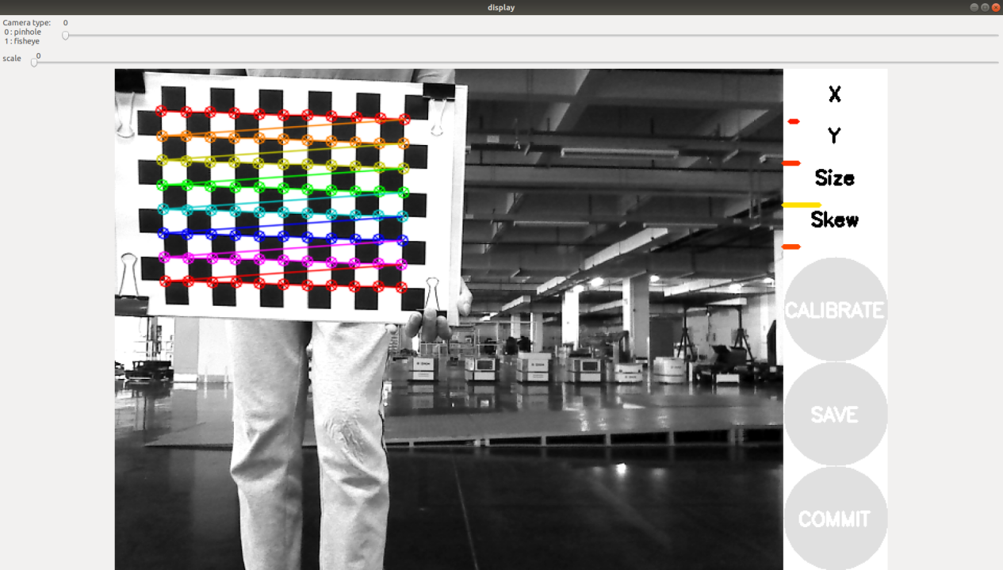

Figure 1

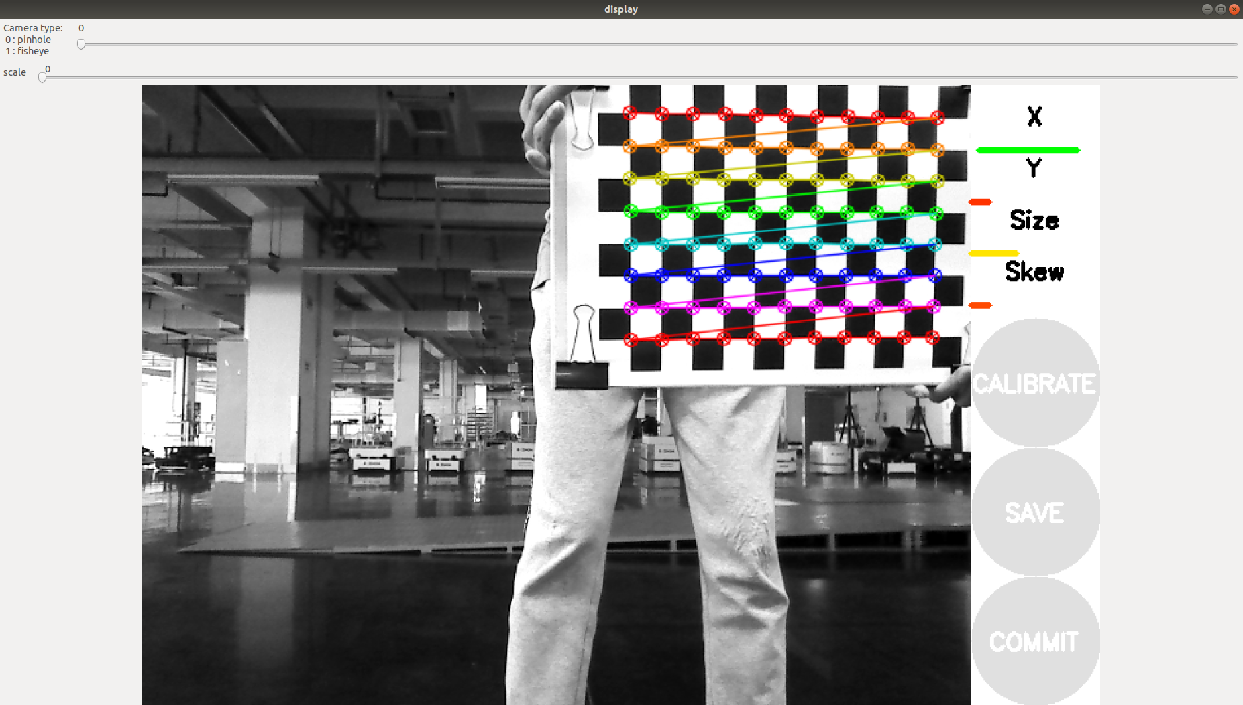

Figure 2

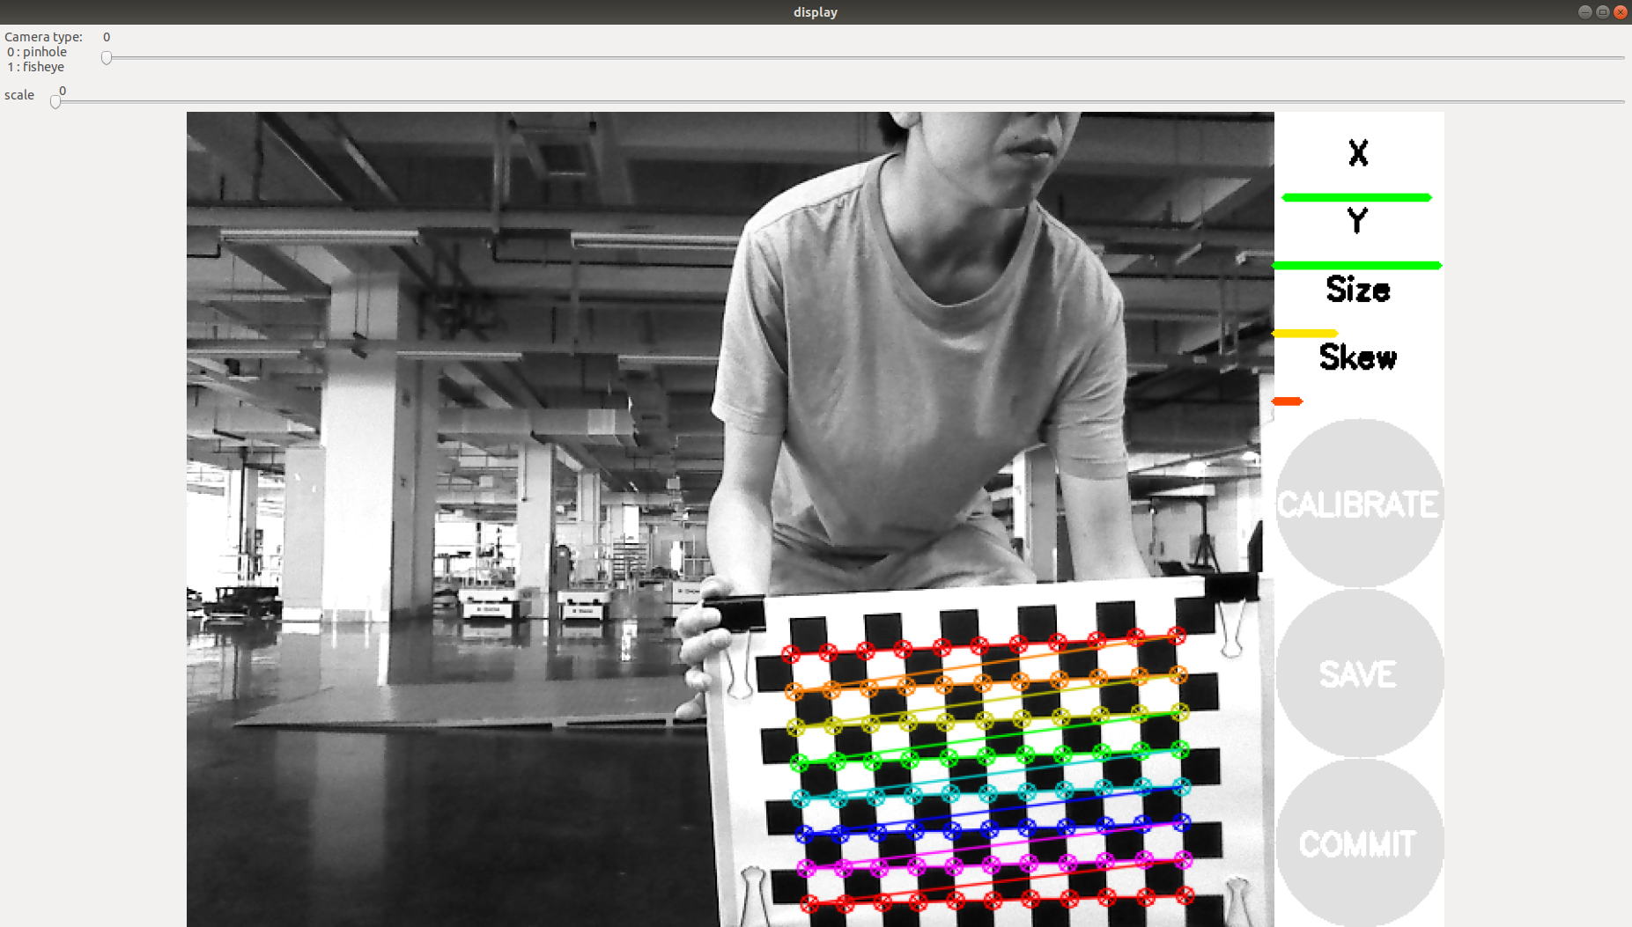

Figure 3

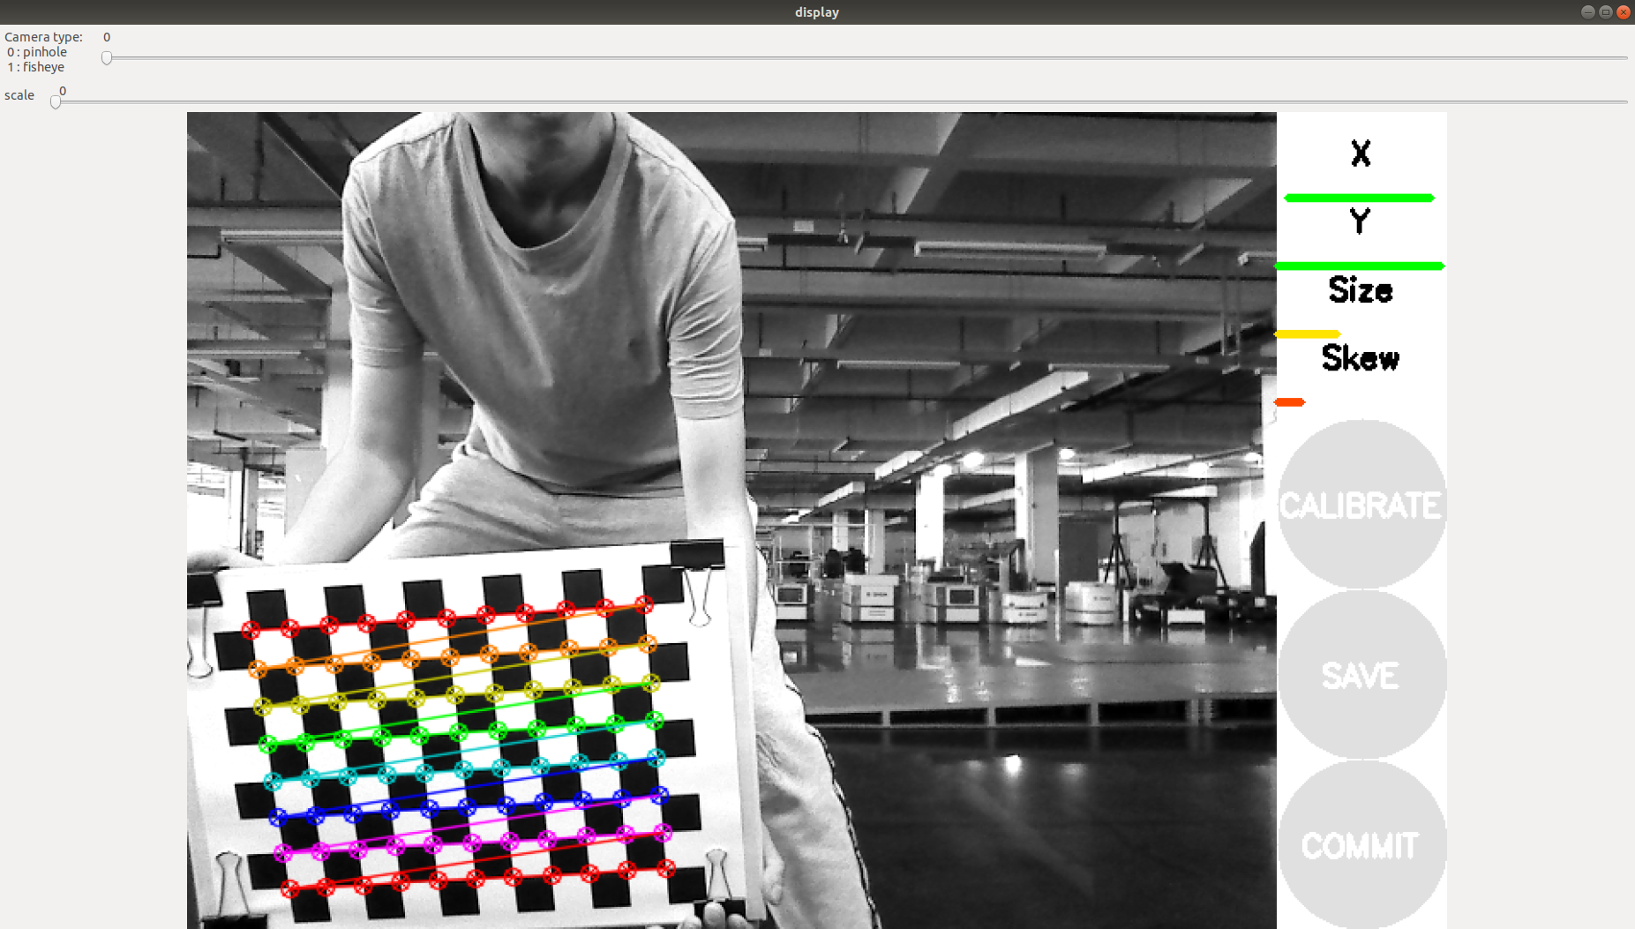

Figure 4

* + 1. **Size Calibration**

Move the checkerboard slowly toward the camera.

Continue until the checkerboard nearly fills the image and the size indicator turns fully green (Figure 5).

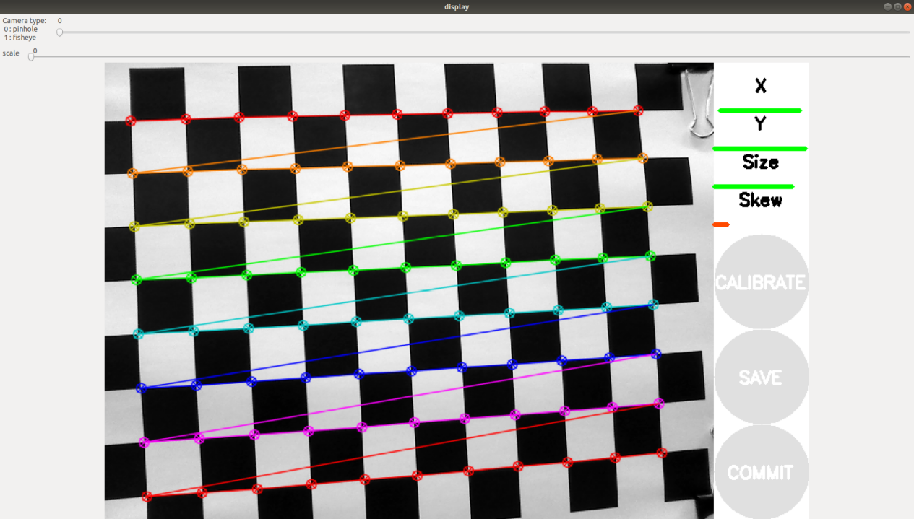

Figure 5

* + 1. **skew的标定**

Step back to the distance where the checkerboard is clearly visible (not too close to the camera). Slowly tilt the checkerboard upward until the skew indicator turns fully green (Figure 6). 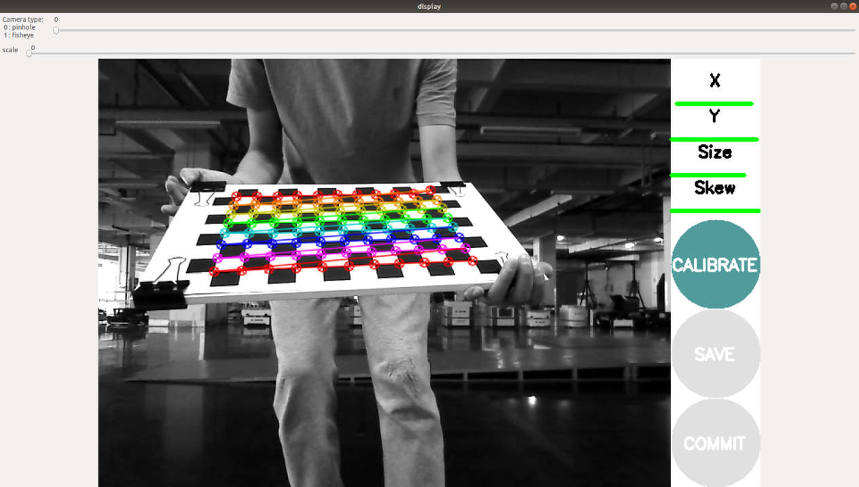

Figure 6

* 1. **Getting Calibration Results**

Click Calibrate to compute the camera parameters.

Click Save to store the results.

The saved calibration files will be located under the directory shown in Figure 7. 

Figure 7

1. **Updating Config and Launch Files**
   1. **Update the Config File**

Choose the config file that matches your camera model.

* For depth cameras or USB cameras, use the **pinhole** model.

Update the config file based on:

* the intrinsic calibration results,
* the checkerboard specification,
* the path where your rosbag data is stored (Figure 8).

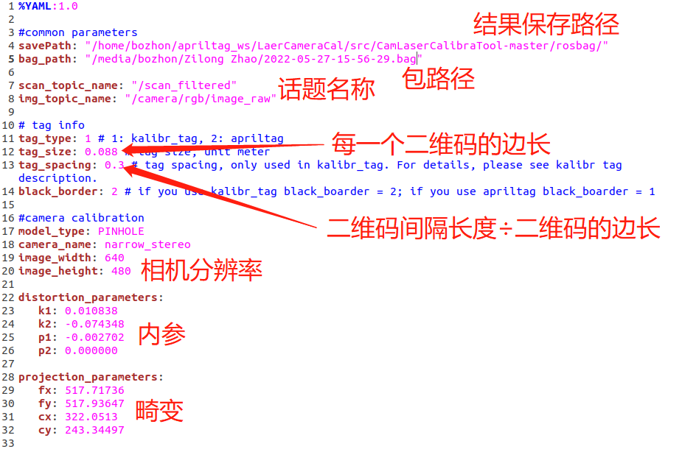

Figure 8

* 1. **Update the Launch Files**

There are three launch files (Figure 9).

* In each launch file, modify the config_path parameter (Figure 10).
* Set config_path to the path of the config file updated in Section 2.1.

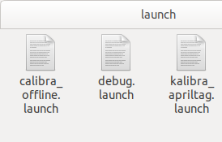

Figure9



Figure 10

1. **Recording Calibration Data (ROS Bag)**
   1. **Command**

*rosbag record /<camera_image_topic> /<laser_topic>*

* 1. **Recording Procedure**
* Stand about **1 m** in front of the laser scanner.
* Place the checkerboard upright on one edge so that it initially appears in the **center** of the image (Figure 11).
* If the camera and laser are very far apart, you can flip the checkerboard upside down so that the QR code is at the top (Figure 12).
* The overall calibration flow is almost the same; any differences are noted separately in blue text in the original document.

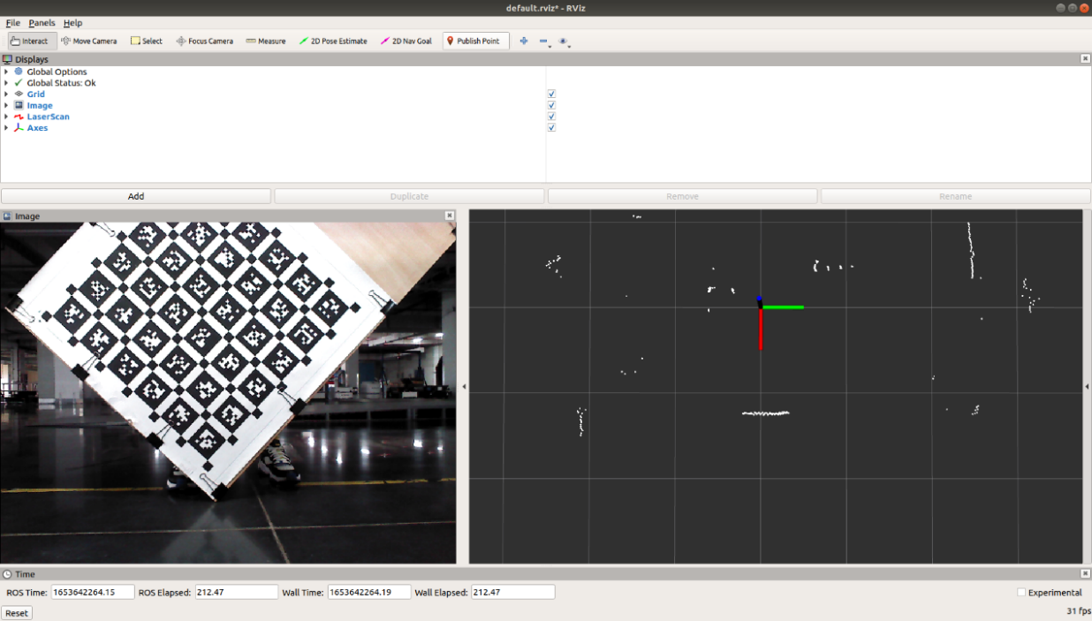

Figure 11

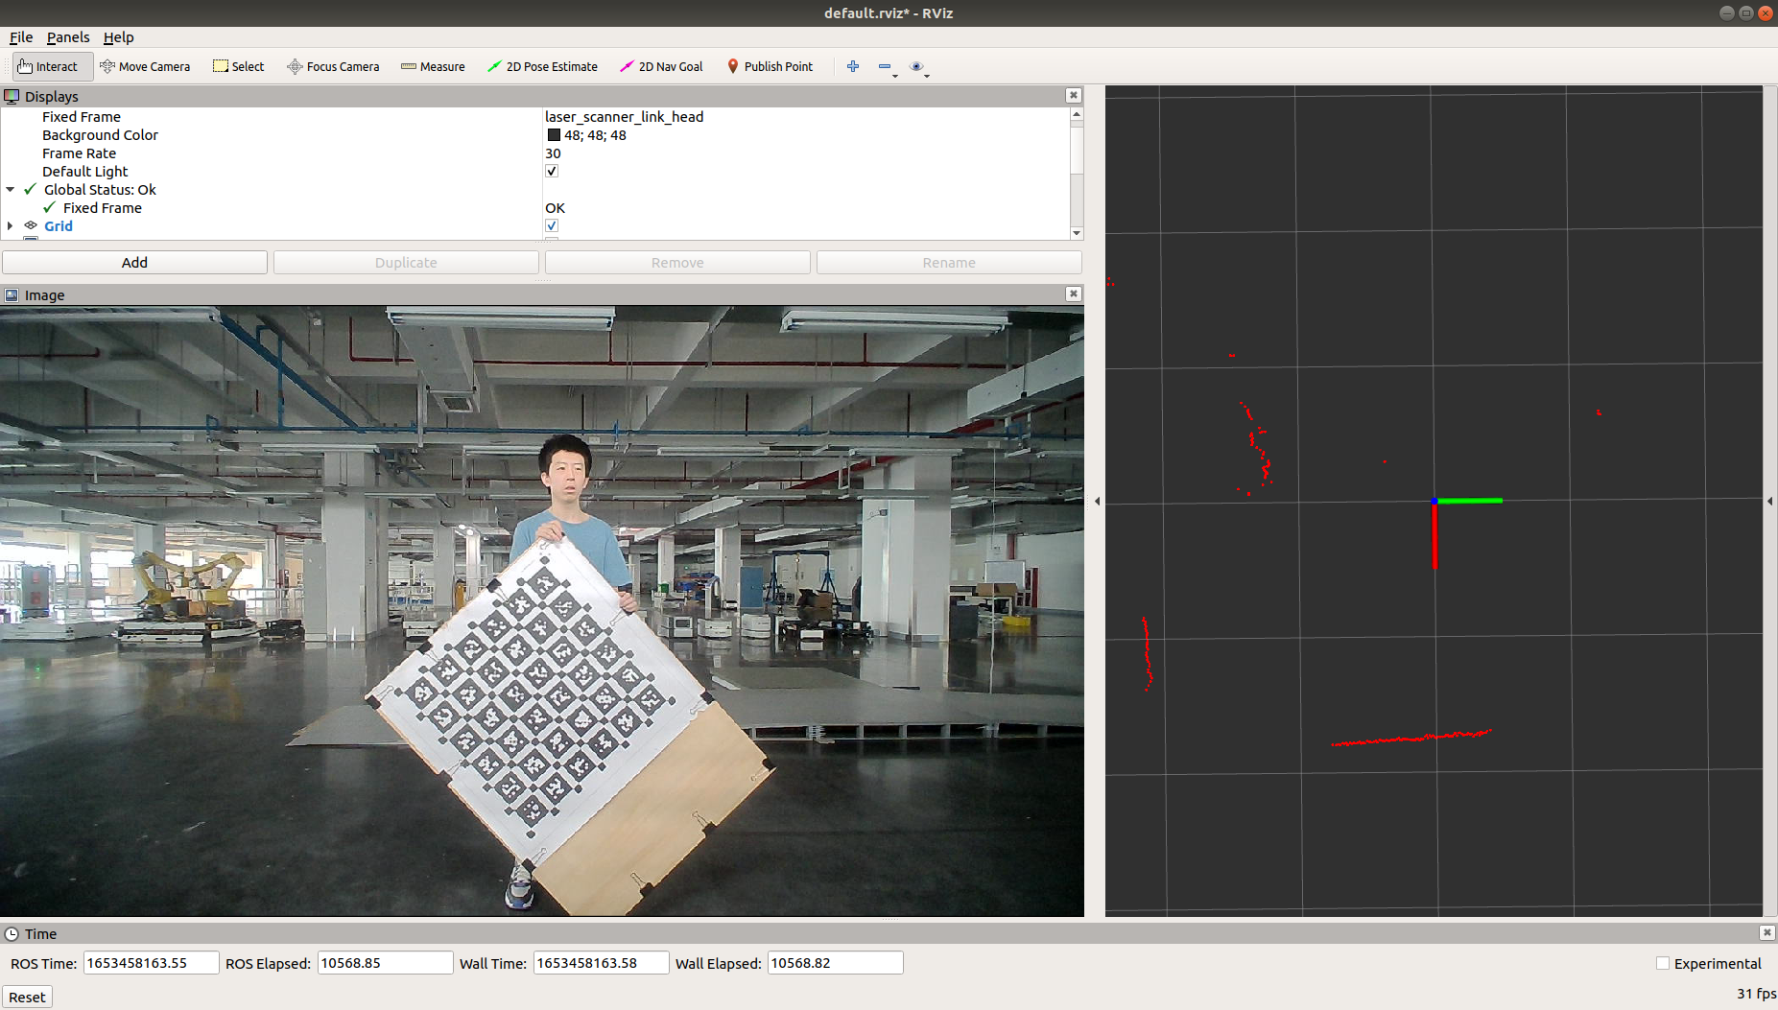

Figure 12

Define a right-handed coordinate system:

* x-axis: forward, pointing in front of the camera,
* y-axis: to the **left** of the camera,
* z-axis: **upward**.

**Rotation About the Z-Axis**

* Rotate the checkerboard around the **z-axis** (yaw).
* Do **not** rotate by a very large angle (see Figures 13 and 14).

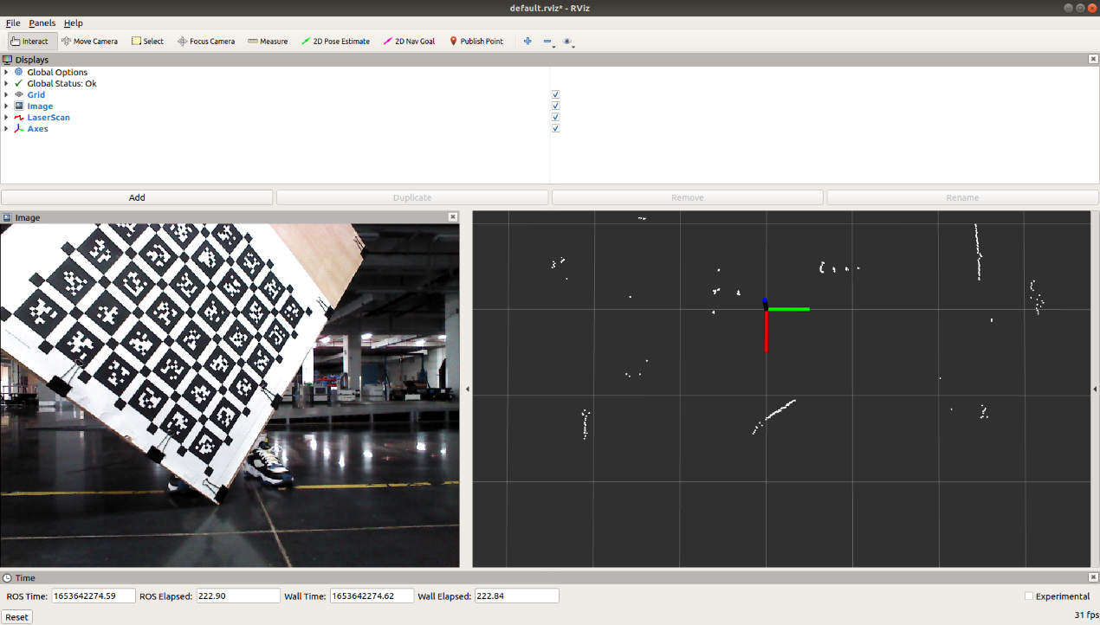

Figure 13

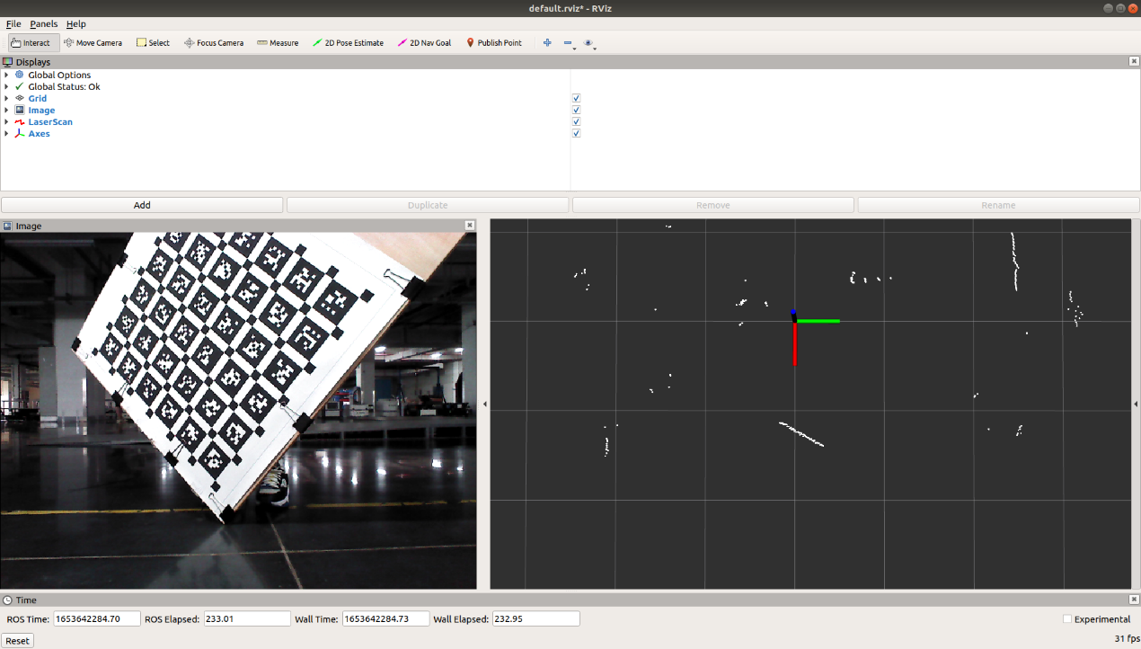

Figure 14

Rotate the checkerboard about the **y-axis** (pitch), as shown in Figures 15 and 16.

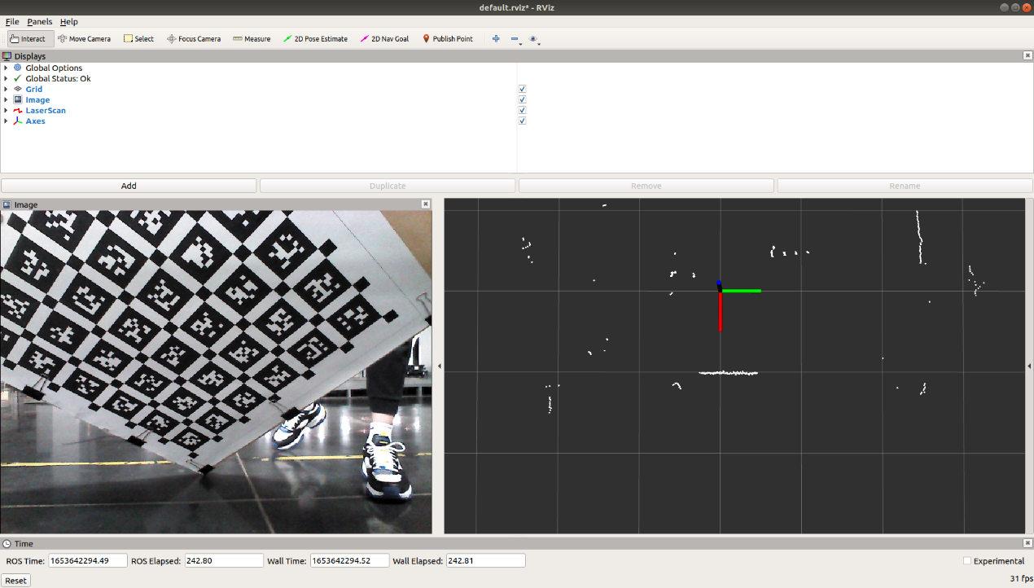

Figure 15

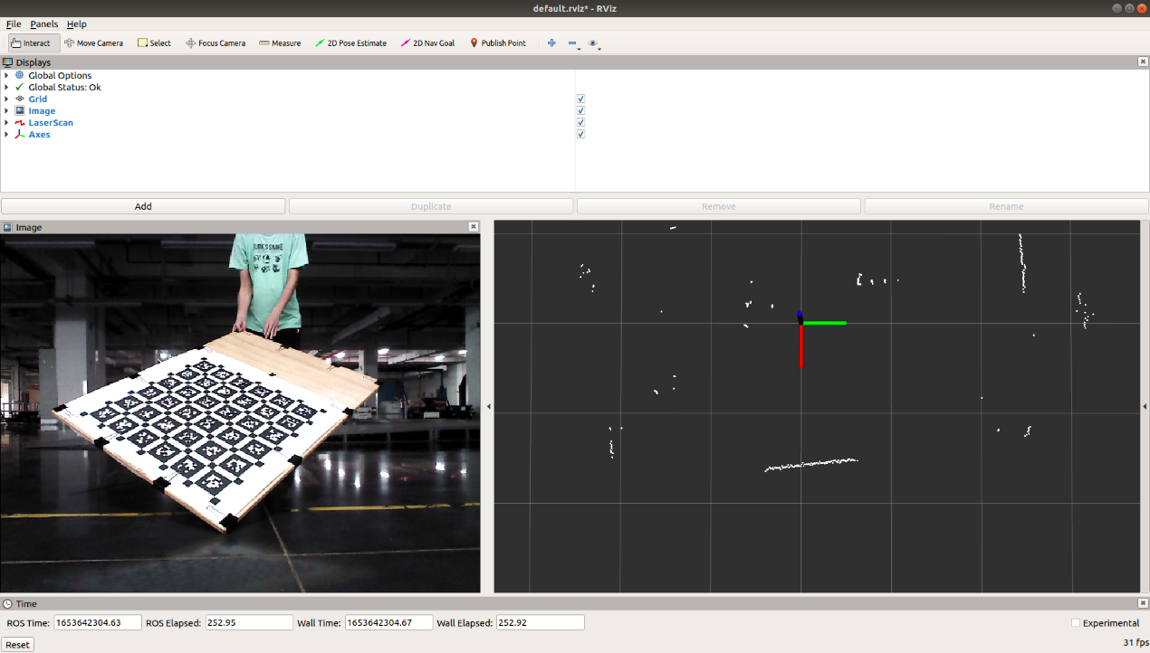

Figure 16

**Rotation About the X-Axis**

* Rotate the checkerboard about the **x-axis** (roll), as in Figures 17 and 18.
* If there are too few QR codes in the image, slightly lift the checkerboard to bring more QR codes into the camera’s field of view.

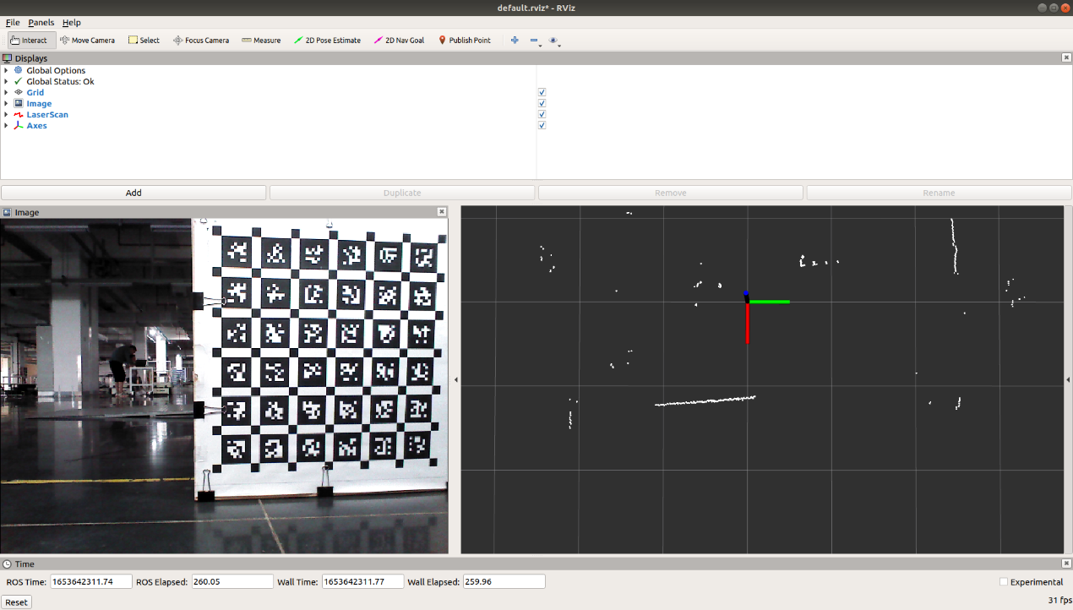

Figure 17

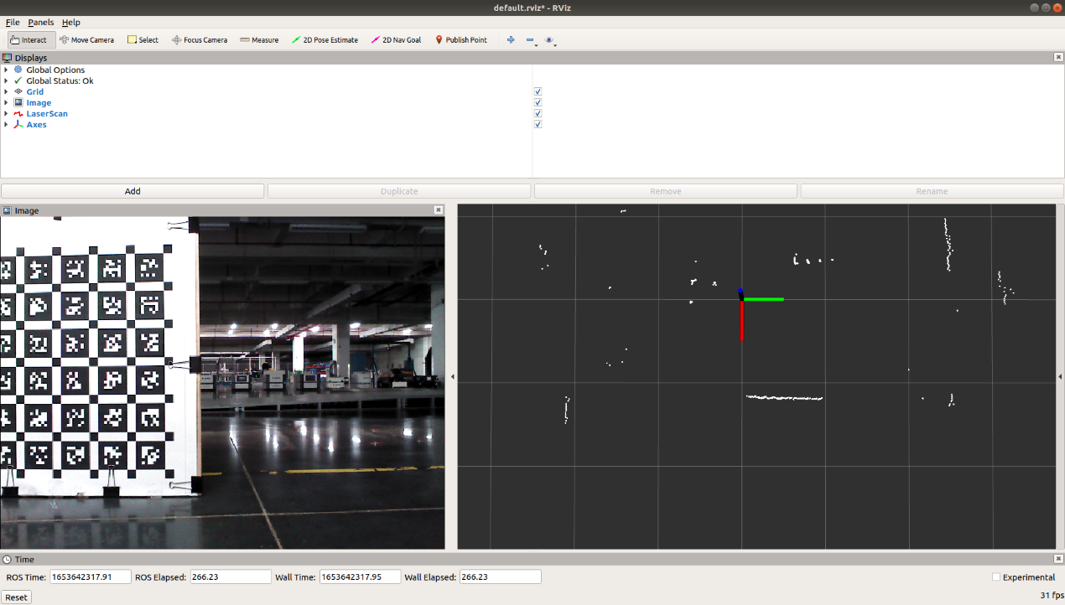

Figure 18

Translate the checkerboard along the **z-axis** while also adding left–right rotation (Fig 19, 20, 21).

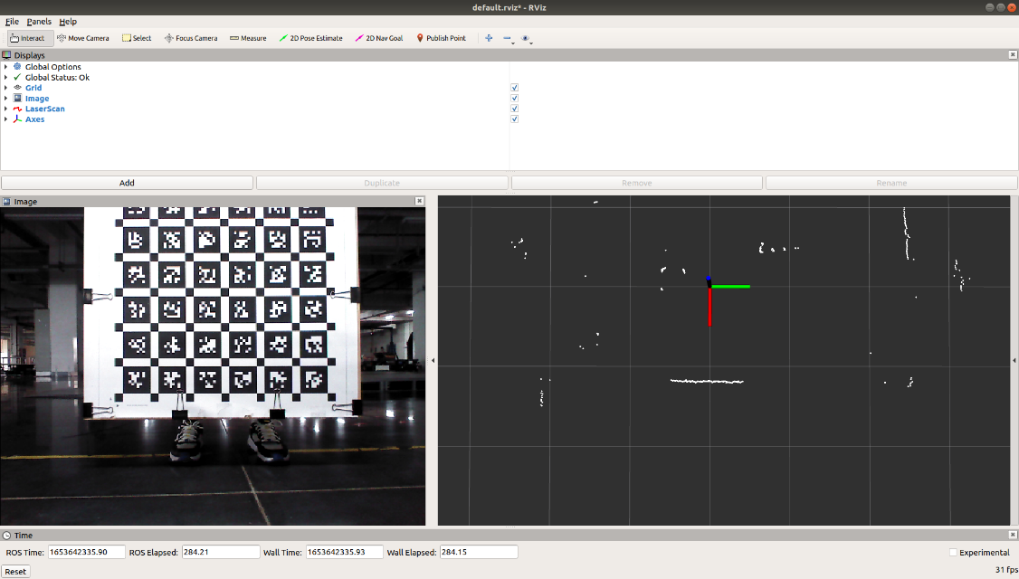

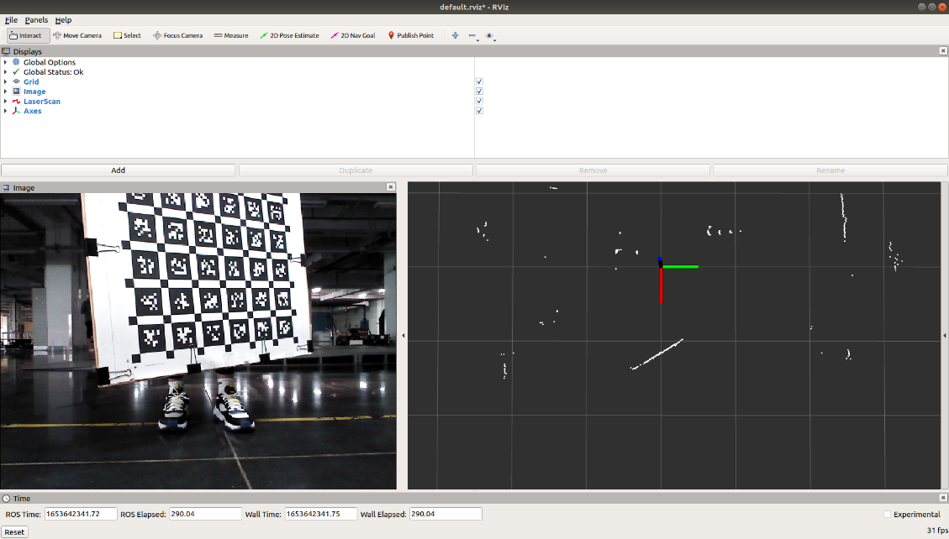

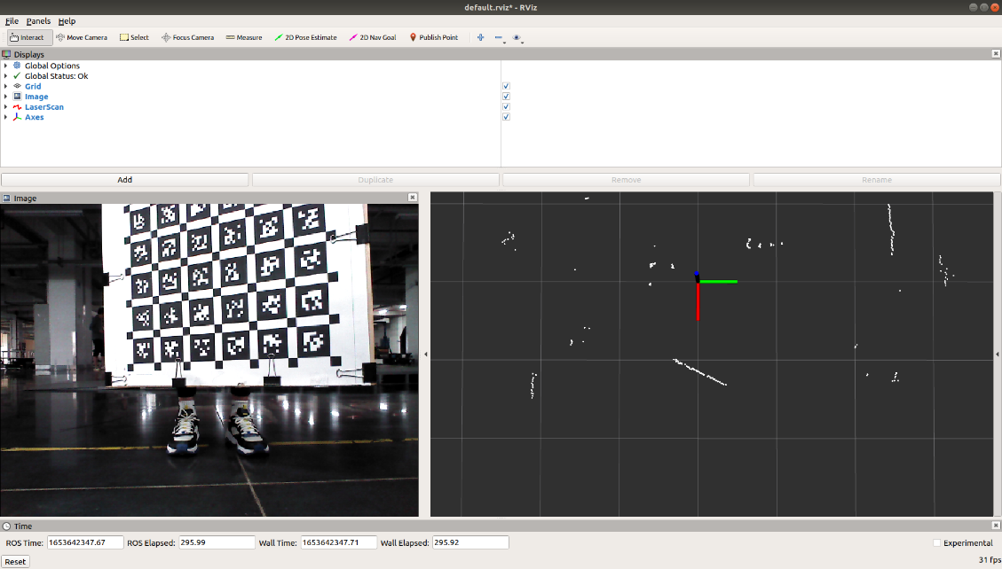

Figure 19，20，21

Then place the checkerboard perpendicular to the ground, with the short edge touching the ground.

Put both hands at about 3/4 of the checkerboard height from the ground.

Treat the line between your hands as a rotation axis and rock the board forward and backward around this axis so that the checkerboard fills the entire image (Figures 22 and 23).

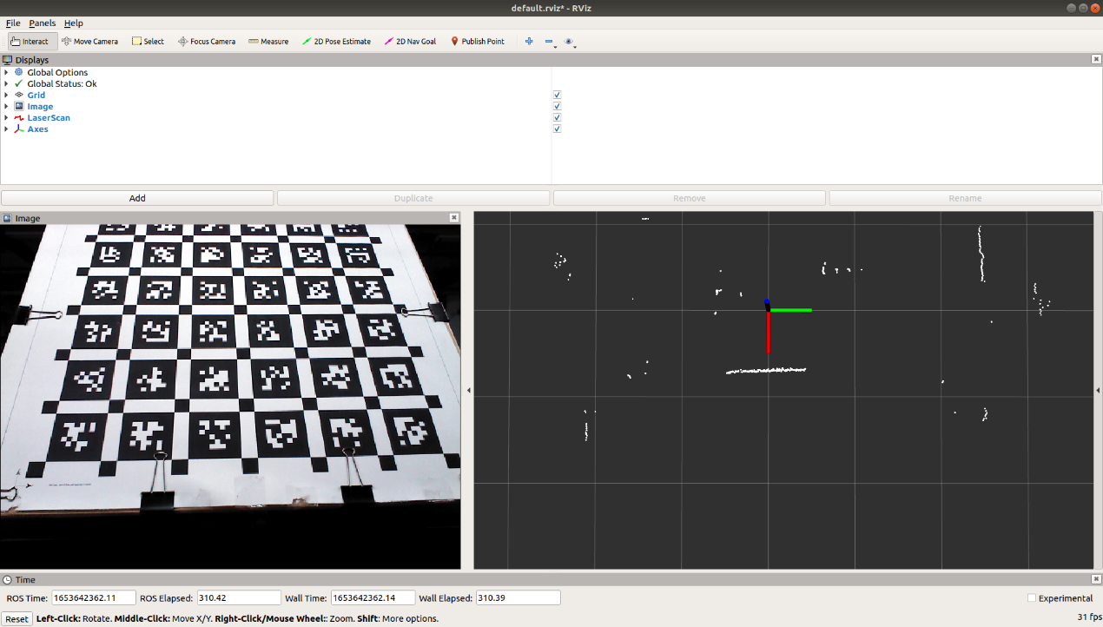

Figure 22

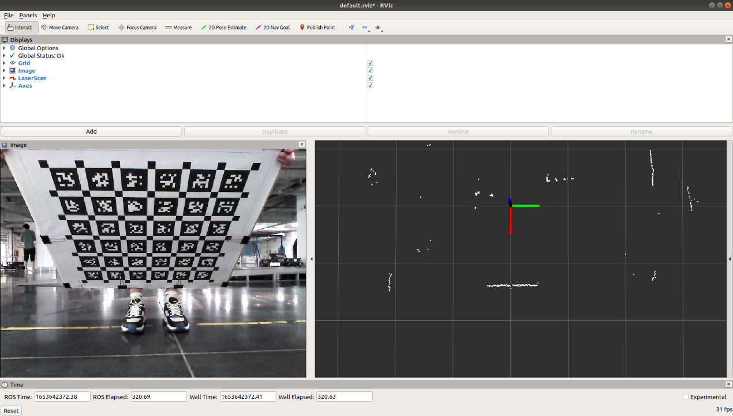

Figure 23

Finally, place the checkerboard near the left and right image borders and rotate it once while facing the camera at each side (Figures 24 and 25).

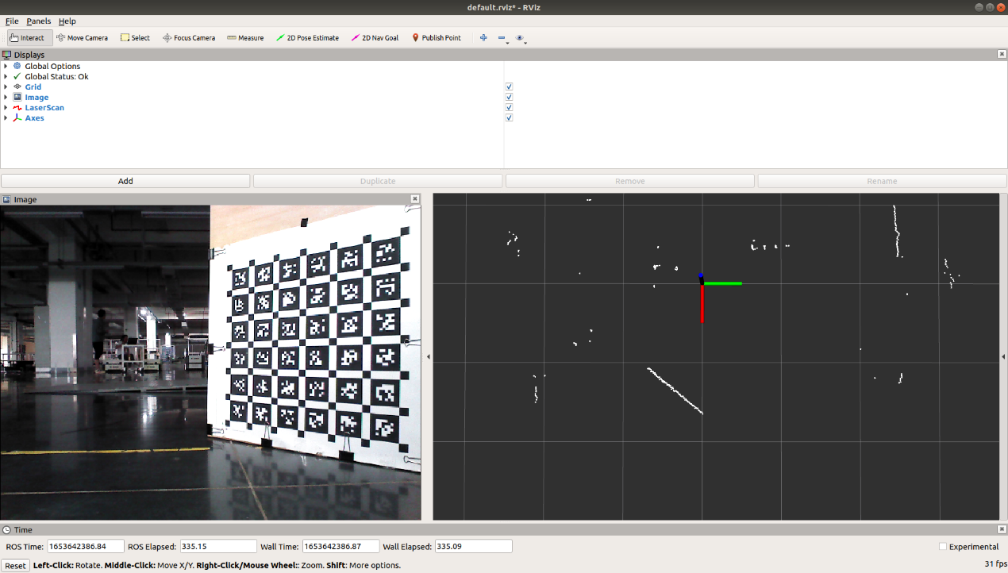

Figure 24

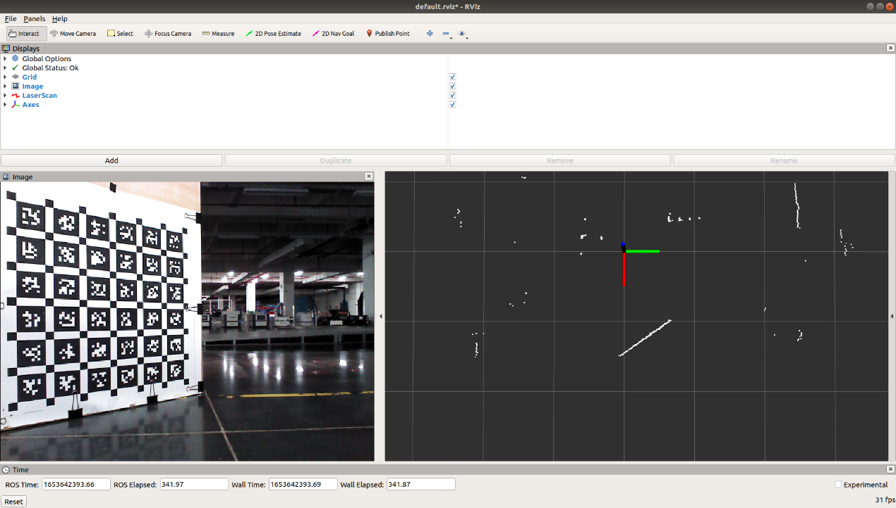

Figure 25

Ensure that during the whole process:

* the laser scanner always sees the checkerboard,
* and the camera captures all motions with sufficient coverage and diversity.

1. **Joint Camera–Laser Calibration**

* Run kalibra_apriltag.launch to obtain the checkerboard (AprilTag) pose file.
* Run calibra_offline.launch to compute the extrinsic parameters of the camera with respect to the laser scanner.
* Run debug.launch and play back one of the recorded bags to visually inspect the calibration result.

If the projected laser points align well with the checkerboard and scene edges in the camera image, the joint calibration is considered successful.